EXERCISE – 15 (DBSCAN CLUSTERING)
1. AIM
To perform DBSCAN clustering on the heart disease dataset, identify the clusters and noise points, and visualize the clustering result using PCA.
2. ALGORITHM
1. Load the dataset and separate the target.
2. Identify the numerical and categorical features.
3. Scale the numerical features and one-hot encode the categorical features.
4. Apply DBSCAN with eps = 1.5 and min_samples = 5.
5. Assign the cluster labels, identify the noise points and count the clusters.
6. Apply PCA to reduce the data to two dimensions and plot the clustering result.
3. PROGRAM
import pandas as pd
import matplotlib.pyplot as plt
from sklearn.compose import ColumnTransformer
from sklearn.preprocessing import StandardScaler, OneHotEncoder
from sklearn.cluster import DBSCAN
from sklearn.decomposition import PCA
df = pd.read_csv("heart_disease_dataset.csv")
print("Dataset Shape:", df.shape)
print("\nFirst 5 records:")
print(df.head())
X = df.drop("Heart Disease", axis=1)
numeric_features = X.select_dtypes(
include=["int64", "float64"]
).columns
categorical_features = X.select_dtypes(
include=["object"]
).columns
preprocessor = ColumnTransformer(
transformers=[
("num", StandardScaler(), numeric_features),
("cat", OneHotEncoder(handle_unknown="ignore"), categorical_features)
]
)
X_processed = preprocessor.fit_transform(X)
X_processed = X_processed
dbscan = DBSCAN(
eps=1.5,
min_samples=5
)
labels = dbscan.fit_predict(X_processed)
df["Cluster"] = labels
print("\nCluster Labels:")
print(df["Cluster"].value_counts().sort_index())
noise_points = df[df["Cluster"] == -1]
print("\nNumber of Noise Points:")
print(len(noise_points))
print("\nNoise Points:")
print(noise_points.head(10))
number_of_clusters = len(
set(labels)
) - (1 if -1 in labels else 0)
print("\nNumber of Clusters:")
print(number_of_clusters)
pca = PCA(n_components=2)
X_pca = pca.fit_transform(X_processed)
plt.figure(figsize=(9, 6))
plt.scatter(
X_pca[:, 0],
X_pca[:, 1],
c=labels,
cmap="viridis",
s=40
)
plt.xlabel("Principal Component 1")
plt.ylabel("Principal Component 2")
plt.title("DBSCAN Clustering")
plt.colorbar(label="Cluster")
plt.show()

4. OUTPUT
The program was executed on the Heart disease dataset (heart_disease_dataset.csv) and produced the following output:
Dataset Shape: (1000, 16)
First 5 records:
Age Gender ... Chest Pain Type Heart Disease
0 75 Female ... Atypical Angina 1
1 48 Male ... Typical Angina 0
2 53 Male ... Atypical Angina 1
3 69 Female ... Non-anginal Pain 0
4 62 Female ... Asymptomatic 0
[5 rows x 16 columns]
Cluster Labels:
Cluster
-1 1000
Name: count, dtype: int64
Number of Noise Points:
1000
Noise Points:
Age Gender Cholesterol ... Chest Pain Type Heart Disease Cluster
0 75 Female 228 ... Atypical Angina 1 -1
1 48 Male 204 ... Typical Angina 0 -1
2 53 Male 234 ... Atypical Angina 1 -1
3 69 Female 192 ... Non-anginal Pain 0 -1
4 62 Female 172 ... Asymptomatic 0 -1
5 77 Male 309 ... Asymptomatic 1 -1
6 64 Female 211 ... Typical Angina 1 -1
7 60 Female 208 ... Asymptomatic 1 -1
8 37 Female 317 ... Non-anginal Pain 0 -1
9 63 Male 204 ... Asymptomatic 1 -1
[10 rows x 17 columns]
Number of Clusters:
0
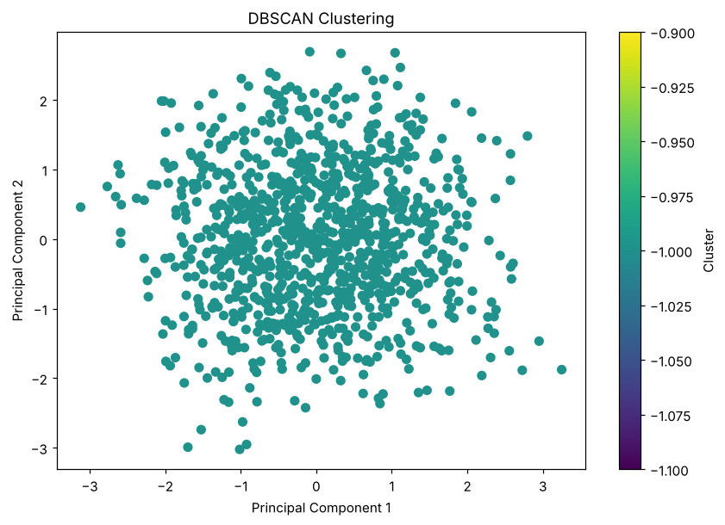

5. RESULT
Thus, the DBSCAN Clustering practical was implemented successfully. With eps = 1.5 and min_samples = 5, no point had five neighbours within that distance in the 27-dimensional feature space, so all 1000 records were labelled as noise and no cluster was formed.

